eFoilgc Access Statement

At eFoilgc we believe that adventure should be accessible to all. We aim to break down barriers and empower individuals with disabilities to experience the jo of eFoil and Jetboard riding. We are committed to creating an inclusive environment where everyone can thrive.

In this statement, we aim to accurately describe our offering so you can decide if it suits your specific requirements.

Getting Here

We run our rides from the eastern end of Winders Park at Currumbin. Winders Park is on Duringan Street. You can get to the park on public transport or by car.

If you’re taking public transport, there is a bus stop less than 20 metres from our launching point.

There is public parking but no designated accessible parking nearby. You can drop off close by.

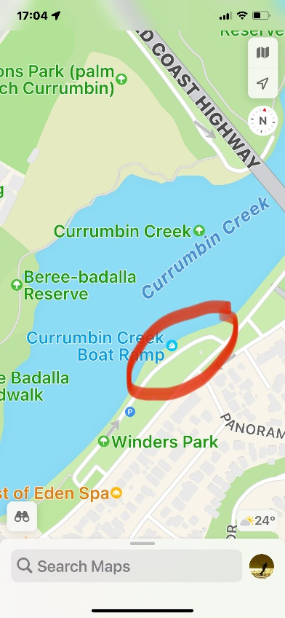
eFoilgc operates from the eastern end of Winders Park
The Experience

eFoilgc provides one on one instruction and the ride can be tailored to individual abilities.

You will be provided with a board that will best suit your needs.

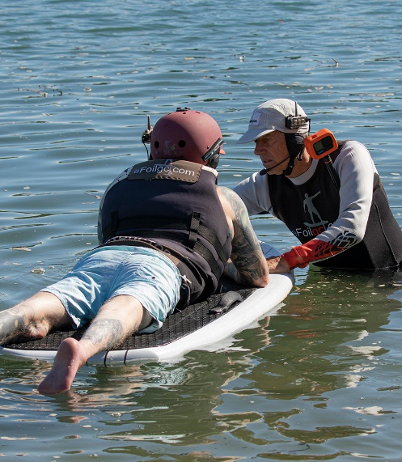
One on one instruction and assistance
You will need to have enough upper body strength to be able to hang on to the board and transfer your weight back and forward. You will also need to be able to use the hand control to operate the board.

Your instructor will accompany you on a separate board. You will be provided with a headset for communication. Your instructor will be in radio contact with you at all times.

We can also offer escorted rides. For these rides, you are the passenger, and the board is controlled by the instructor.

You will get wet, and it can be cold at times, so if you have a wetsuit, please bring it along. If you do not have a wetsuit we can provide you with a rashie. You will be fitted with a life vest.

The entry point to the water changes depending on the tide. There is some sand to cross to get to the water’s edge. eFoilgc staff will help transfer you if needed.

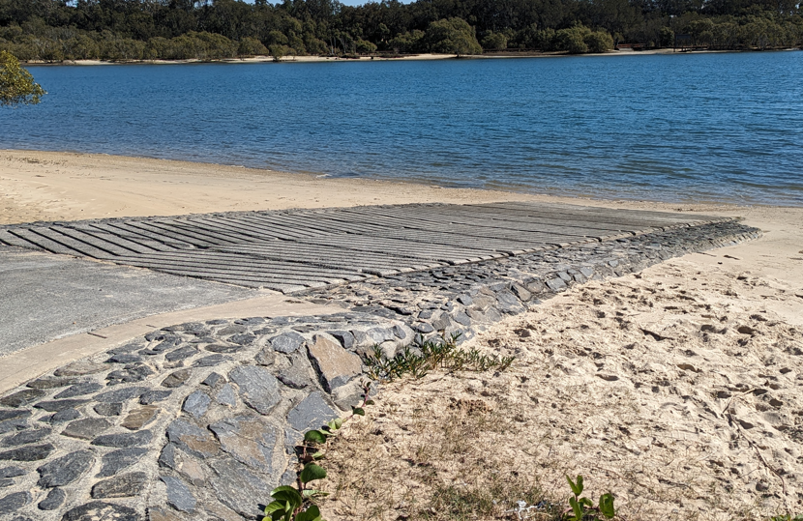
Boat ramp at low tide
There is also a boat ramp nearby of a moderate gradient. The surface is grooved. The boat ramp is another option for entry to the water.

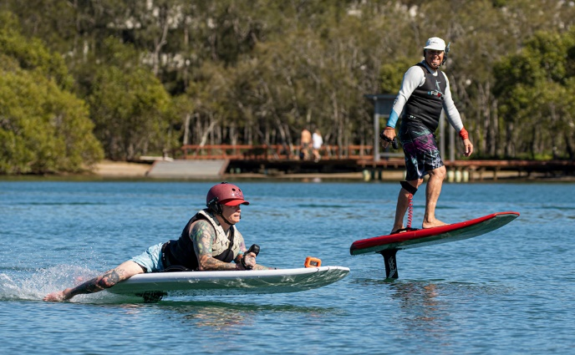
Rider with instructor alongside

The on shore assessment and instruction will take up to 25 minutes to complete. You will then be on the water for at least 25 minutes.

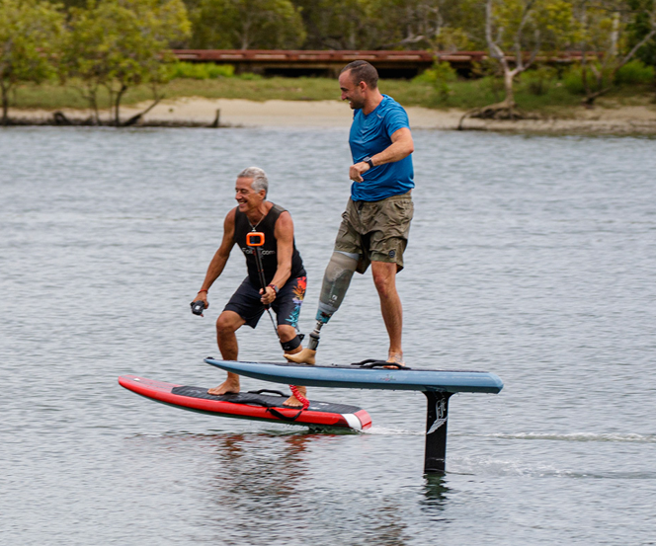
A rider having the board ‘foiling’

While you are on the water your instructor can take photos of you. You will be given the photos at no extra cost.

A video will also be taken and can be purchased at a separate cost.

Booking

If you have access requirements, we recommend you phone us to make your booking. We can discuss your needs during the call which will help us to understand how we can best support you to enjoy your eFoil experience.

Amenities

There is a public amenity block approximately 300 metres from the launching point. It includes a right hand unisex accessible toilet.

There is a beach shower approximately 150 metres from the launching point.

